Boot Camp announcement
Hi, recruits! Boot Camp is coming soon! Are you excited?
First, here is your packing list!
- Clothes [sufficient for 3 days of sweaty activities]
- Sport shoes and slippers
- Socks [sufficient for 3 days]
- Toiletries
- Hanger
- Water bottle of 1.5L (Important! Stay hydrated!)
- Stationery
- BB handbook
- Notebook
- Bible
- Medication [if needed]
- Sleeping bag
- Mestin/utensils/cup [preferably plastic ones]
- Polishing kit [Kiwi, Brasso/Autosol and 2 pieces of old cloth]
- Cloth hanger. At least 2.
Please LABEL your items so it doesn’t get mixed up/lost/missing

Here is the list of items not allowed at camp
- Any electronic items (Inform your parents to contact Sir Vincent.)
- Cards/Board games
- Weapons/Explosives(other than your knives for cooking; please be very careful!!!)
- Huge amount of money [ >RM20]

These are a few items that you would need during boot camp:
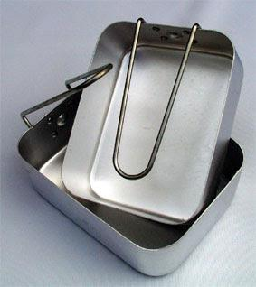
- Mestin [can be bought at shops that sell camping tools]
- Brasso/Autosol (get either one from hardware or DIY shops)
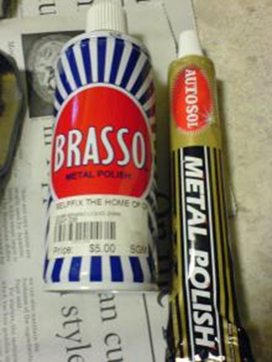
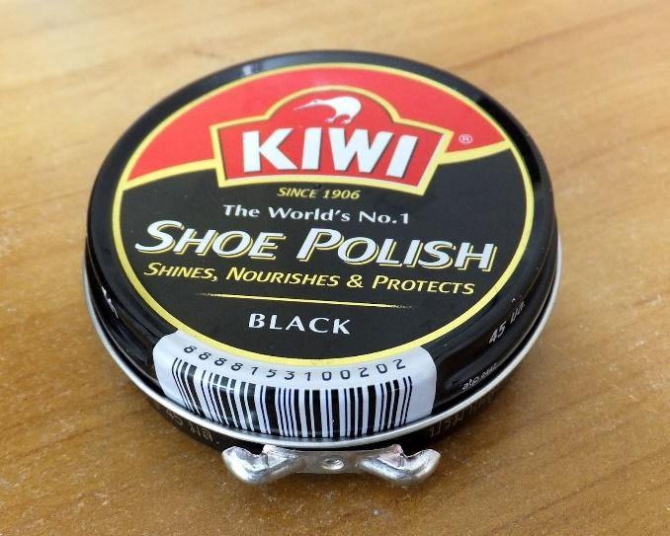
- Kiwi (can get from hardware shops)
- 1 Smooth cloth
- 1 Rough cloth

Next, there will be a fire starting class! Please bring
1. A bundle of wood, big diameter.
2. A bundle of twigs and branches
3. Newspaper or leaves.
Make sure the amount you bring is sufficient for you to start a fire and keep it going for at least 30mins.
*Reminders*
1) Day 1(22/3/18): Fall in at 9am sharp in the basketball court. Come in your recruit uniform!
2) Remember to inform your parents to pick you up at 1pm on 24/3/2018.
Thank you! Have a great week :)
-LCpl Sarah Low-

